**Project Report**

**Alumni Management System**

**Submitted by**

**Rana Junaid Hashim**

**MCS-E-22-27**

**2022-2024**

**Supervised by**

**Dr. Muzaffar Hameed**



DEPARTMENT OF COMPUTER SCIENCE

**BAHAUDDIN ZAKARIYA UNIVERSITY MULTAN PAKISTAN**

**FINAL APPROVAL**

This is to certify that we have read this report titled **“Alumni Management System”** submitted by ***Rana Junaid Hashim MCSE-22-27*** and it is our judgment that this report is of sufficient standard to warrant its acceptance by Bahauddin Zakariya University, Multan for the degree of MCS (Master of Computer Science).

# *Committee:*

**1. External Examiner ______________________**

<<Examiner Name>>  
<<Designation>>  
<<Organization>>

**2. Supervisor ________________**

Prof. Dr. Muzaffar Hameed  
Assistant Professor,  
Department of Computer Science

.

**3. Head of Department ________________**

Prof. Dr. Minhaj Ahmad Khan  
Chairman /Professor ,  
Department of Computer Science

Bahauddin Zakariya University, Multan.

**Declaration**

I declare that this written submission represents my ideas in my own words and where other ideas or words have been included, I have adequately cited and referenced the original sources. I also declare that I have adhered to all principles of academic honesty and integrity and have not misrepresented or fabricated or falsified any idea/data/fact/source in my submission. I understand that any violation of the above will be cause for disciplinary action by the Institute.

Rana Junaid Hashim

MCSE-22-27

Date :

# ABSTRACT

The Alumni Management System for the Department of Computer Science at Bahauddin Zakariya University Multan is designed to improve communication and connections between the university department and its graduates. This system not only allows the university to stay in touch with its alumni but also helps alumni connect with each other and share their professional profiles publicly.

The system collects and updates information about the careers of alumni and includes a job notification feature. Whenever the admin posts a job, all alumni are notified through email. This helps alumni in their professional growth and keeps them engaged with the university. With a focus on ease of use, the system offers an online dashboard to manage information about both recent and older graduates efficiently.

The main goal of this project is to create a comprehensive Alumni Management System that supports the registration, search, and management of alumni data. This allows alumni to share their knowledge, network, job opportunities, and resources. By using React Js, Node Js, and Express Js with a MySQL database, the system provides a strong, scalable, and user-friendly platform for the Department of Computer Science at Bahauddin Zakariya University Multan.

**Table of Contents**

CHAPTER 01 1

INTRODUCTION 2

CHAPTER 02 4

TECHNOLOGIES 5

HTML 5

CSS 6

Bootstrap 6

React JS 7

Node JS 7

MySQL 7

XAMPP 8

CHAPTER 03 9

SYSTEM DESIGN & ANALYSIS 9

3.1 System Design 10

3.2 Use Case Diagram 11

3.3 Sequence Diagram 13

3.2 ER Diagram 16

CHAPTER 04 17

Database 17

4.1 Database 18

4.1.1 Advantages of Database 18

4.2 Normalizing Relational Model to 3NF 19

4.2.1 Normalization 19

4.2.2 Types of Normalization 19

4.3 Database Tables 20

4.3.1 Table: Alumnus 20

4.3.2 Table: Courses 20

4.3.3 Table: Careers 20

4.3.4 Table: Events 21

4.3.5 Table: Event Commits 21

4.3.6 Table: Forums Topics 21

4.3.7 Table: Forum Comments 21

4.3.8 Table: Gallery 22

4.3.9 Table: Users 22

4.3.10 Table: About 22

CHAPTER 05 23

USER’S GUIDE 23

5.1 Homepage 24

5.2 Admin Page 25

5.3 Login Page 29

5.4 Alumni Page 30

CHAPTER 06 33

TESTING & EVALUATION 33

6.1 Introduction 34

6.2 Strategic Approach To Software Testing 34

6.3 Evaluation of Testing 36

CHAPTER 07 40

CONCLUSION 40

7.1 Summary 41

7.2 Findings 41

7.3 Objective 42

7.4 Future Scope 42

7.5 Conclusion 42

CHAPTER 08 43

REFERENCES 44

**Chapter 1**

**Introduction**

* 1. **Introduction**

The Alumni Management System is an easy-to-use web application built with React Js, Node Js, and Express Js with a MySQL database for the Computer Science department of BZU Multan. This project has 2 sides of users UI (user interface), which are the admin side management and the alumnus/alumna's side. The admin side can manage all the list of jobs posted, alumni list, events, forum topics, and the gallery. The alumni site can create an account (to be verified by admin), post a job opportunity, create a forum topic, and join other forums, commit to participate in an upcoming event such as Sports Gala. The alumni will be notified when the job is posted by admin through the email. Talking about the flow of the Alumni Management System, computer science alumni will register to the website and this process will need the verification of the university management in order to enlist the alumnus/alumna in the website user.

After the admin will verify the user as an alumnus of the alumni user can begin to explore the features or functionalities of the system on their side which are the job opportunities posted by other alumni or admin, a list of upcoming events, joining to the forum with the other alumni. For the administrator side of the system, aside from verifying the account and list of alumni, the admin also will manage the gallery to be displayed on the website and the gallery may contain some images of the university events with a short description. The admin will create the about content of the university to be displayed also on the website, this feature helps the university management update the about content of the system easily even without the presence of a developer. The admin can also post a job opportunity and can overwrite or manage the posted job and forum topic of an alumnus/alumni if any instances may occur.

* 1. **Problem Definition:**

The product will begin in a way that multiple passouts as well students of the Computer Science department of Bahauddin Zakariya University Multan can register. After registration, they will become a valid user only when they are verified by the admin successfully. The user will be able to see different post, upcoming events , gallery etc.The alumni can post about various jobs available in their company and thus other students will benefit from it. The information related to various post can also be viewed by admin. The admin here becomes responsible for posting various information related to the upcoming events, gallery etc.

* 1. **Features**

**Admin Side**

* + - **Login Page :** The page where system admin will submit their system credential to access and manage the system data.
    - **Home Page :** The page is dashboard where the admin user will be redirected by after logging into the alumni management system admin side. This page displays the total counts of alumni, posted jobs, forum topics, and upcoming events along with a sidebar to navigate between the pages.
    - **Gallery Page :** The page where the admin user will manage the gallery images and data for the website.
    - **Course List :** The page where the admin will add and manage the university courses.
    - **Alumni List :** The page where the alumni list in the system is listed and this the page where the admin can verify the alumnus/alumna's account.
    - **Jobs Page :** The page where all posted jobs are listed and can be managed by the admin.
    - **Events Page :** The page where an admin manages or posts an upcoming event of the university where alumni can participate.
    - **Job Emails:** Alumni will get notified through email when job is posted by admin.
    - **Forum Page :** The page where all forum topics are listed along with the count of comments if this topic is being shown.
    - **User Page :** The page where an admin user manages the system users.
    - **About Page :** The page where an admin manages the university and CS department information to be shown on the website.

**Alumni Side**

* **Home Page :**The default page where the user will be redirected when browsing the website and after logging in. This page shows the list of upcoming events.
* **Signup Page :**The page where the unregistered alumnus/alumni submit their credentials.
* **Login Page :** The page where the user submits their system credential in order to access and manage the other features or functionalities of the system.
* **Gallery Page** : The page where the images posted by the university 's management is being shown.
* **About Page :** The page where the page about content is being shown.
* **Job Page :** The page where all posted job opportunities are listed.
* **Forum Page :** The page where that forum topics are listed and the user can join or read the comments by viewing a topic.
* **Account Management Page:** The page where the user can update his/her system credentials and information.

**Chapter 2**

**Technologies**

* 1. **Technologies to be used**

**Following Tech Stack Used:**

* + - * HTML, CSS :- For frontend/UI
      * Bootstrap :- For responsiveness and styling.
      * React Js :- For frontend/UI
      * Node Js :- For server-side scripting and API development
      * MySQL :- For relational database management

### HTML:

Hypertext Markup Language (HTML) is the standard markup language used to create the structure and content of web pages. It consists of a series of elements that define the different parts of a webpage, such as headings, paragraphs, images, links, and forms. HTML elements are structured using tags, which are enclosed in angle brackets. These tags define the semantics and hierarchy of the content, allowing web browsers to render it properly.

HTML elements are the building blocks of HTML pages. With HTML constructs, images and other objects such as interactive forms may be embedded into the rendered page. HTML provides a means to create structured documents by denoting structural semantics for text such as headings, paragraphs, lists, links, quotes and other items. HTML elements are delineated by tags, written using angle brackets. Tags such as <img /> and <input /> directly introduce content into the page. Other tags such as <p>...</p> surround and provide information about document text and may include other tags as sub-elements. Browsers do not display the HTML tags, but use them to interpret the content of the page.

HTML can embed programs written in a scripting language such as JavaScript which affects the behavior and content of web pages. Inclusion of CSS defines the look and layout of content.

### CSS:

Cascading Style Sheets (CSS) is a style sheet language used to define the presentation and layout of HTML documents. It allows developers to specify the visual appearance of elements on a webpage, including properties such as colors, fonts, margins, padding, and positioning. CSS works by applying styles to HTML elements using selectors, which target specific elements based on their attributes, classes, or IDs. By separating content from presentation, CSS enables developers to create consistent and visually appealing user interfaces across different devices and screen sizes.

CSS is designed primarily to enable the separation of presentation and content, including aspects such as the layout, colors, and fonts. This separation can improve content accessibility, provide more flexibility and control in the specification of presentation characteristics, enable multiple HTML pages to share formatting by specifying the relevant CSS in a separate .css file, and reduce complexity and repetition in the structural content. Separation of formatting and content makes it possible to present the same markup page in different styles for different rendering methods, such as on-screen, in print, by voice (via speech-based browser or screen reader), and on Braillebased tactile devices. It can also display the web page differently depending on the screen size or viewing device. Readers can also specify a different style sheet, such as a CSS file stored on their own computer, to override the one the author specified.

### Bootstrap:

Bootstrap is a free and open-source front-end framework for building responsive and mobile-first web projects. It provides a collection of pre-designed HTML and CSS templates, as well as JavaScript plugins, that streamline the process of designing and developing web interfaces. Bootstrap's grid system allows developers to create responsive layouts that automatically adapt to different screen sizes, ensuring a consistent user experience across desktops, tablets, and smartphones. Additionally, Bootstrap includes a wide range of UI components, such as buttons, forms, navigation bars, and carousels, that can be easily customized and extended to fit the needs of a project

### React JS:

React is a JavaScript library developed by Facebook for building user interfaces. It enables developers to create reusable UI components that can be composed together to build complex interfaces. React uses a declarative and component-based approach to UI development, where each component encapsulates its own state and behavior. This makes it easier to manage the state of an application and keep the UI in sync with the underlying data. React also introduces a virtual DOM (Document Object Model), which is a lightweight representation of the actual DOM. This allows React to efficiently update only the parts of the DOM that have changed, resulting in better performance and a smoother user experience.

### Node JS:

Node.js is an open-source, cross-platform JavaScript runtime environment that allows developers to run JavaScript code on the server-side. It uses Chrome's V8 JavaScript engine to execute code with high performance and scalability. Node.js is event-driven and non-blocking, meaning it can handle multiple simultaneous connections without blocking the execution of other code. This makes it well-suited for building real-time web applications, APIs, and microservices. Node.js has a rich ecosystem of npm (Node Package Manager) modules, which are reusable libraries and tools that extend its functionality. It is commonly used for server-side scripting, API development, and building scalable web applications.

### MySQL:

MySQL is an open-source relational database management system that is widely used for storing and managing structured data. It follows the relational model, where data is organized into tables with rows and columns, and relationships between tables are established using foreign keys. MySQL provides a powerful set of features for managing databases, including support for transactions, indexes, stored procedures, and triggers. It uses SQL (Structured Query Language) as its primary interface for querying and manipulating data. MySQL is scalable, reliable, and easy to use, making it a popular choice for web development projects that require a relational database backend.

### XAMPP:

It is a free and open-source cross-platform web server solution stack package developed by ApacheFriends, consisting mainly of the Apache HTTP Server, Maria DB database, and interpreters for scripts written in the PHP and programming languages.XAMPP stands for CrossPlatform(X),Apache(A),Maria DB(M),PHP(P)and Perl(P). Xampp is a simple, lightweight Apache distribution that makes it extremely easy for developers to create a local web server for Everything needed to set up a web server application (Apache), database (Maria DB), and scripting language (PHP)-is included in an extractable file. XAMPP is also cross-platform, which means it works equally well on Linux, Mac and Windows. Since most actual web server deployments use the same components as XAMPP, xampp makes transitioning from a local test server to a live server extremely easy as well.

**Chapter 3**

**SYSTEM DESIGN &**

**Analysis**

## 3.1 System Design

System design refers to the process of creating a detailed blueprint or plan for the development of a system. It involves defining the architecture, components, modules, and interactions of the system. The design phase focuses on translating the requirements into a structured and organized design that ensures the system's functionality, scalability, maintainability, and performance. The system design incorporates various considerations, such as the choice of technologies, database design, security measures, and integration with external systems. It serves as a foundation for the implementation and testing phases of the system development life cycle, ensuring a well-structured and efficient system.

* 1. **Use case diagram:**

Use case diagrams show the interaction between use cases, which represent the system functionality, and actors, which represents the people, or systems that provide or receive information from the system. Use Case is the way of interaction of actors with the system.

There are two actors that performing their specific role in the accomplishment of this system. These actors perform actions on the input and generate the output for the next phase. My project includes two types of actors.

1. **Admin**
2. **Alumni**

The Use Case diagrams of this project are given.

**Use Case Diagram for Alumnus**

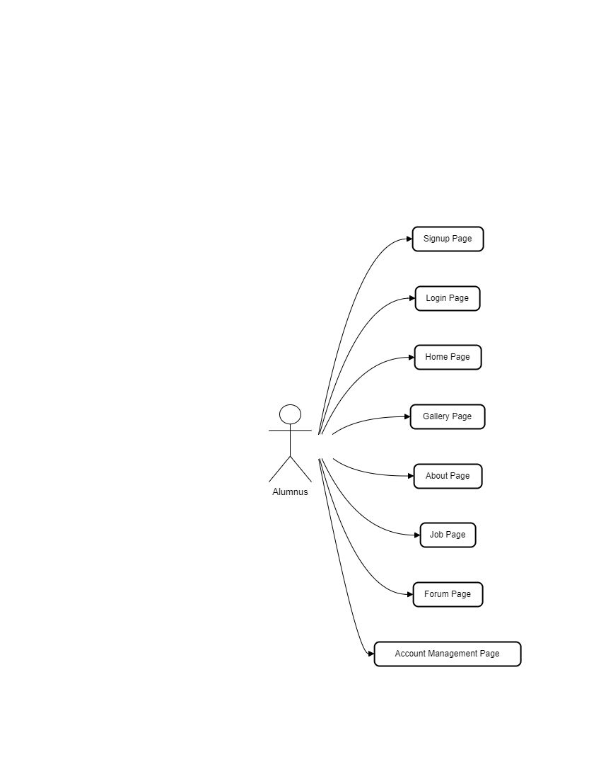

Figure 3.2.1 Use Case diagram (Alumnus)

**Use Case Diagram for Admin**

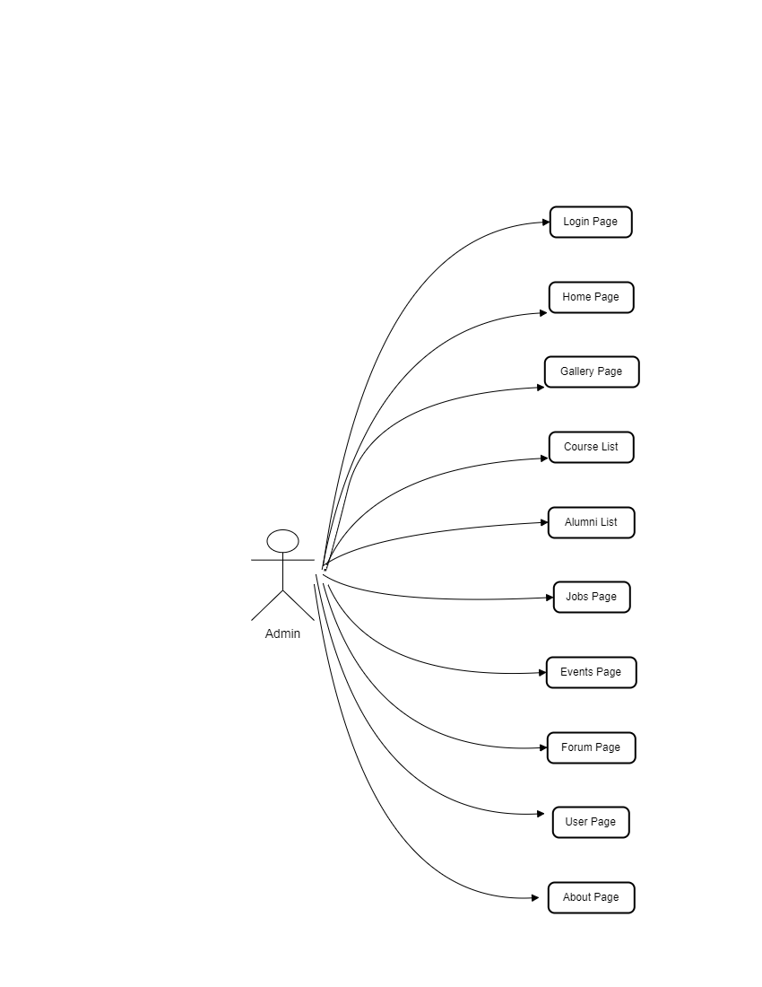

Figure 3.2.2 Use Case diagram (Admin)

**3.3 Sequence diagram:**

Sequence diagram is an interaction diagram. Interaction diagrams address the dynamic view of a system. Sequence diagram emphasizes the time ordering of messages between objects in the system.

There are two actors that performing their specific role in the accomplishment of this system. These actors perform actions on the input and generate the output for the next phase. My project includes two types of actors.

1. **Alumni**
2. **Admin**

Here we will show the Sequence Diagrams of diagrams for both of the objects.

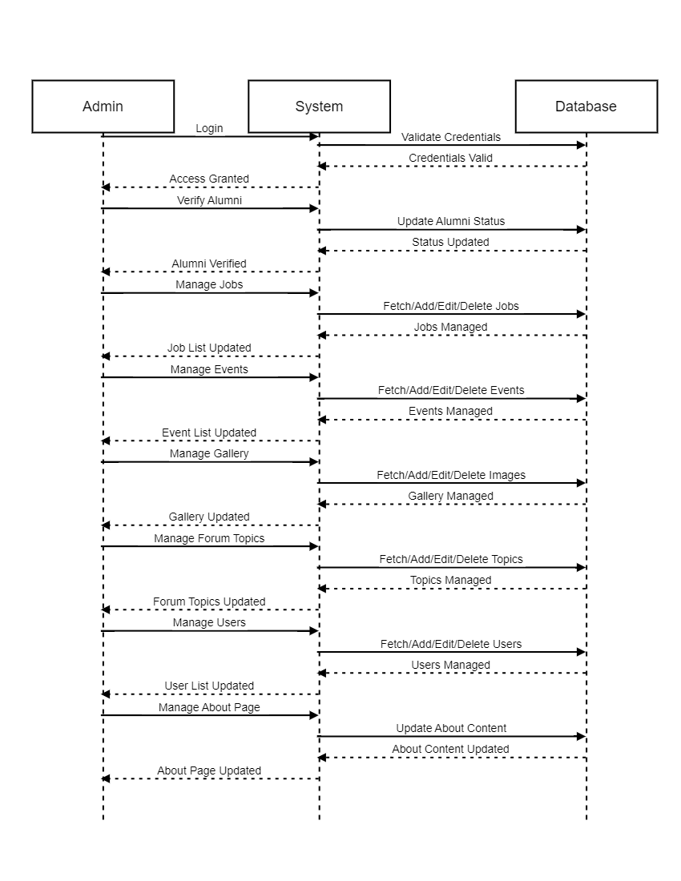**Admin**

Figure 3.3.1 Sequence diagram (Admin)

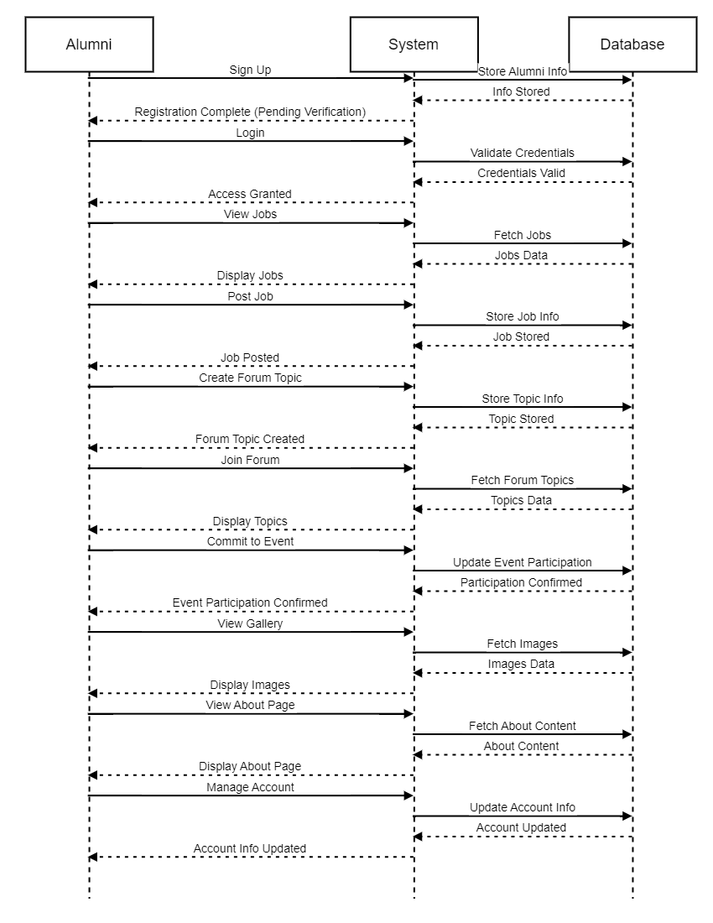Alumni

Figure 3.3.2 Sequence diagram (Alumni)

**3.4 ER diagram:**

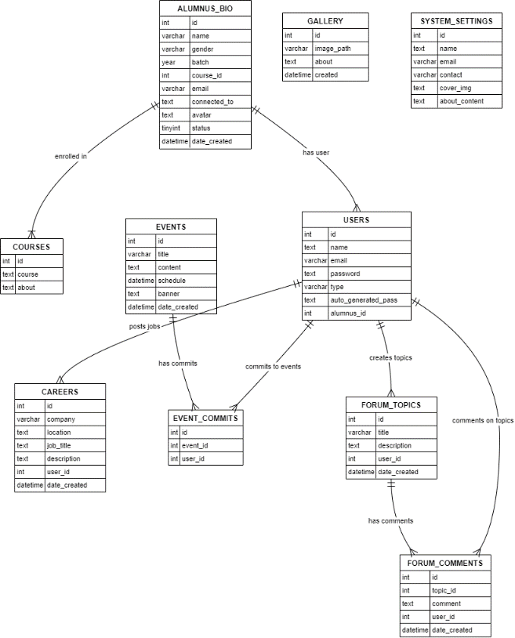The next component of analysis is a detailed entity relationship diagram. A graphical representation of the relationship between the instances of two or more entities is called Entity Relationship Diagram. The ERD enables a software engineer to fully specify the data objects that are input and output from a system, the attributes that define the properties of these objects, and their relationship.

Figure 3.4.1 ER diagram

**Chapter 4**

**Database**

## 4.1 Database

A database is collection of data, which is organized in such a way that each piece of data is available to those who need it and with minimum duplication of data. Another definition in terms of database may be as "A database is a collection of data organized so as to minimize redundancy and maximize access."

### 4.1.1 Advantages of Database

* The most common advantages of database may be as follows:
* Sharing of data
* Ease of application development
* Uniform security, privacy and integrity controls
* Reduced program maintenance

**1-Super Key:**

A super key is an attribute or a set of attributes that uniquely identified an entity. For example, Login name is a super key because it can be used to identify each Admin uniquely.

**2- Primary Key:**

The primary key is one or more column in a table used to uniquely identify each row to the table. Primary key values can't be null and must be unique across the column. A multicolumn primary key is called Composite Primary Key.

**3- Foreign key:**

Foreign key represents relationships between the tables or relations. A foreign key is a column (or a group of columns) whose values are derived from the primary/unique key of the same or some other tables.

**4- Composite Key**

If the key consists of more than one attribute for unique identification then it will be called as composite key.

Before description of tables, it is important to understand normalization.

## 4.2 Normalizing Relational Model to 3NF

### 4.2.1 Normalization

Normalization means putting a relation in to a higher normal. The purpose of normalization is to produce a stable set of relations that is faithful model of operations of the enterprise.

### 4.2.2 Types of Normalization

Following are major types of Normalization

* First Normal Form
* Second Normal Form
* Third Normal Form

**First Normal Form**

A relation is in First Normal Form if and only every attribute is single valued for each tuple. First Normal Forms does not allow any repeating fields. An alternative way of describing first normal form is to say that the domains of the attributes of a relation are atomic.

**Second Normal Form**

A relation is in Second Normal Form if and only if it is INF (first normal form) and all the non-key attributes are fully functionally dependent on the key

**Third Normal Form**

A relation is in third normal form if and only if it is in second normal form and no non-key attribute is transitively dependent on the primary key.

Third Normal Form can be defined as "A relation is in third normal form, if it is in second normal form and remove all transitive dependencies”.

## 4.3 Database Tables

### 4.3.1 Table: alumnus_bio

**Primary key**: Id

|  |  |  |
| --- | --- | --- |
| **Field Name** | **Data Type** | **Constraints** |
| Id | Int | Primary Key |
| name | varchar(255) | Not Null |
| gender | varchar(10) | Not Null |
| batch | year(4) | Not Null |
| email | varchar(250) | Not Null |
| connected_to | text | Not Null |
| avatar | text | Not Null |
| status | tinyint(1) | Not Null |
| date_created | datetime | Not Null |

### 4.3.2 Table: courses

**Primary key**: Id

|  |  |  |
| --- | --- | --- |
| **Field Name** | **Data Type** | **Constraints** |
| Id | int(30) | Primary Key |
| course | varchar(255) | Not Null |
| about | text | Not Null |

### 4.3.3 Table: careers

**Primary key**: Id

|  |  |  |
| --- | --- | --- |
| **Field Name** | **Data Type** | **Constraints** |
| Id | int(30) | Primary Key |
| alumnus_id | int(30) | Foreign Key |
| location | text | Not Null |
| job_title | text | Not Null |
| description | text | Not Null |
| company | varchar(250) | Not Null |
| date_created | datetime | Not Null |

### 4.3.4 Table: events

**Primary key**: Id

|  |  |  |
| --- | --- | --- |
| **Field Name** | **Data Type** | **Constraints** |
| Id | int(30) | Primary Key |
| title | varchar(250) | Not Null |
| content | text | Not Null |
| schedule | datetime | Not Null |
| banner | text | Not Null |
| date_created | datetime | Not Null |

### 4.3.5 Table: event_commits

**Primary key**: Id

|  |  |  |
| --- | --- | --- |
| **Field Name** | **Data Type** | **Constraints** |
| Id | int(30) | Primary Key |
| event_id | int(30) | Foreign Key |
| alumnus_id | int(30) | Foreign Key |

### 4.3.6 Table: forum_topics

**Primary key**: Id

|  |  |  |
| --- | --- | --- |
| **Field Name** | **Data Type** | **Constraints** |
| Id | int(30) | Primary Key |
| alumnus_id | int(30) | Foreign Key |
| title | varchar(250) | Not Null |
| description | text | Not Null |
| date_created | datetime | Not Null |

### 4.3.7 Table: forum_comments

**Primary key**: Id

|  |  |  |
| --- | --- | --- |
| **Field Name** | **Data Type** | **Constraints** |
| id | int(30) | Primary Key |
| alumnus_id | int(30) | Foreign key |
| topic_id | int(30) | Foreign key |
| comment | text | Not Null |
| date_created | datetime | Not Null |

### 4.3.8 Table: gallery

**Primary key**: Id

|  |  |  |
| --- | --- | --- |
| **Field Name** | **Data Type** | **Constraints** |
| Id | int(30) | Primary Key |
| image_path | varchar(255) | Not Null |
| about | text | Not Null |
| created | datetime | Not Null |

### 4.3.9 Table: users

**Primary key**: Id

|  |  |  |
| --- | --- | --- |
| **Field Name** | **Data Type** | **Constraints** |
| Id | int(30) | Primary Key |
| alumnus_id | int(30) | Foreign key |
| name | text | Not Null |
| email | varchar(100) | Not Null |
| password | text | Not Null |
| type | varchar(10) | Not Null |

### 4.3.10 Table: system_settings

**Primary key**: Id

|  |  |  |
| --- | --- | --- |
| **Field Name** | **Data Type** | **Constraints** |
| Id | int(30) | Primary Key |
| name | text | Not Null |
| email | varchar(200) | Not Null |
| contact | varchar(20) | Not Null |
| about_content | text | Not Null |

**Chapter 5**

**USER’S GUIDE**

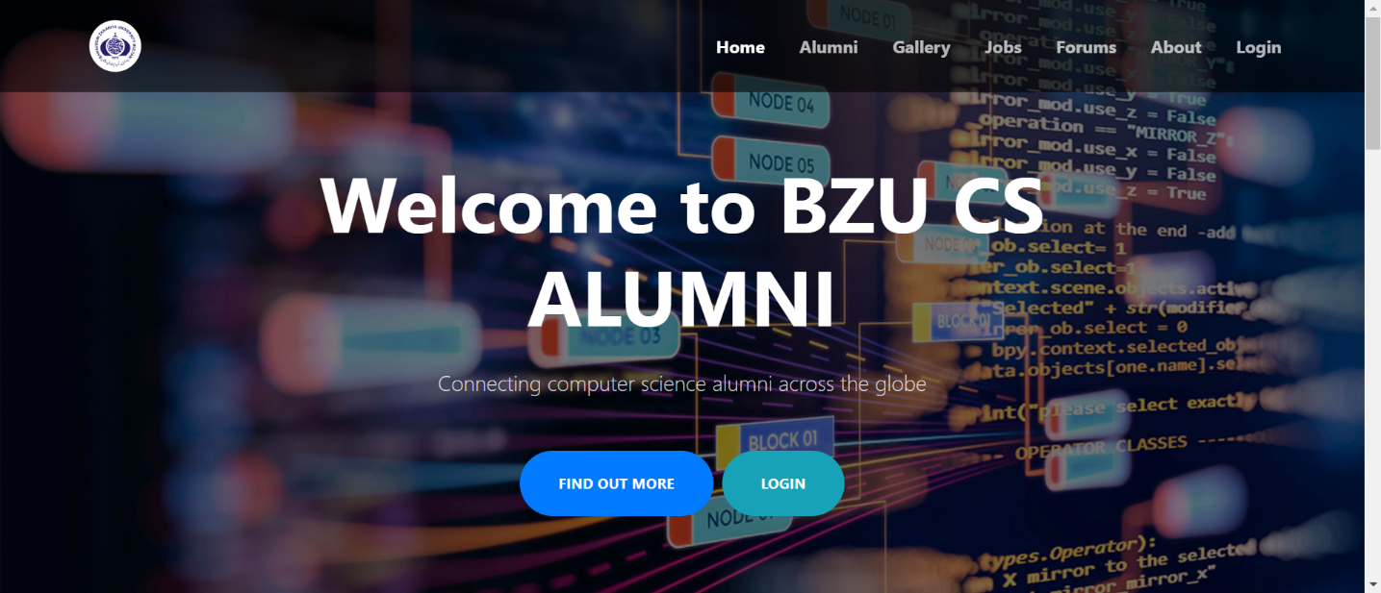**5.1 Homepage:**

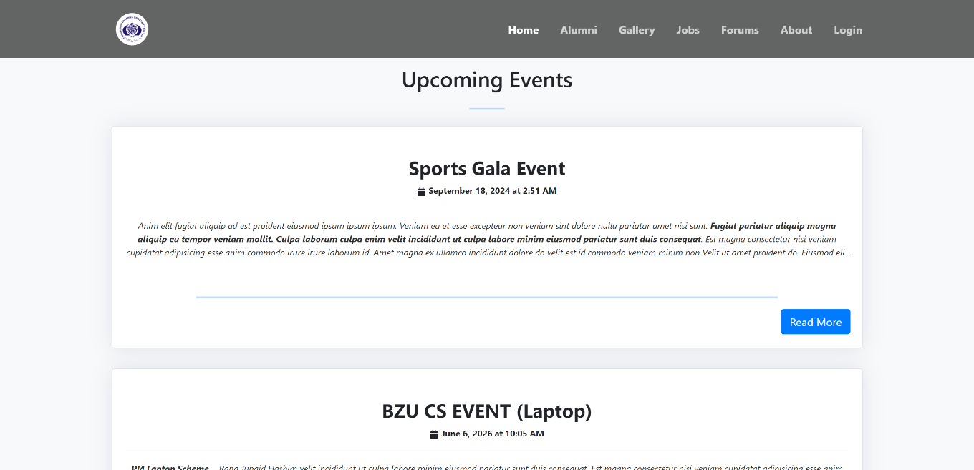Figure 5.1.1 Website Homepage

Figure 5.1.2 Homepage

The purpose of this web page is to serve as a welcoming platform for the Bahauddin Zakariya University Computer Science alumni community, providing information on alumni benefits, upcoming events, and personalized navigation options for logged-in users and administrators. It also includes user notifications for login and logout events.

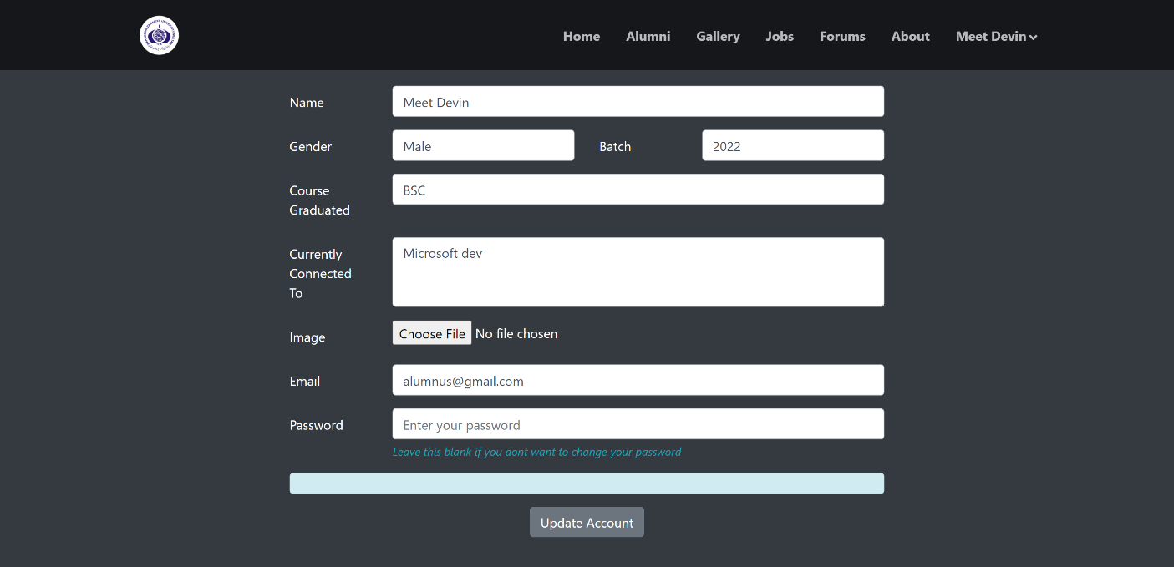**In this manner the user can change credentials:**

Figure 5.1.3 Account Management Page

The My Account page allows users to manage their personal information within the BZU CS Alumni Management System, including updating details like name, gender, email, and profile picture, as well as changing passwords if needed.

**5.2 Admin Dashboard:**

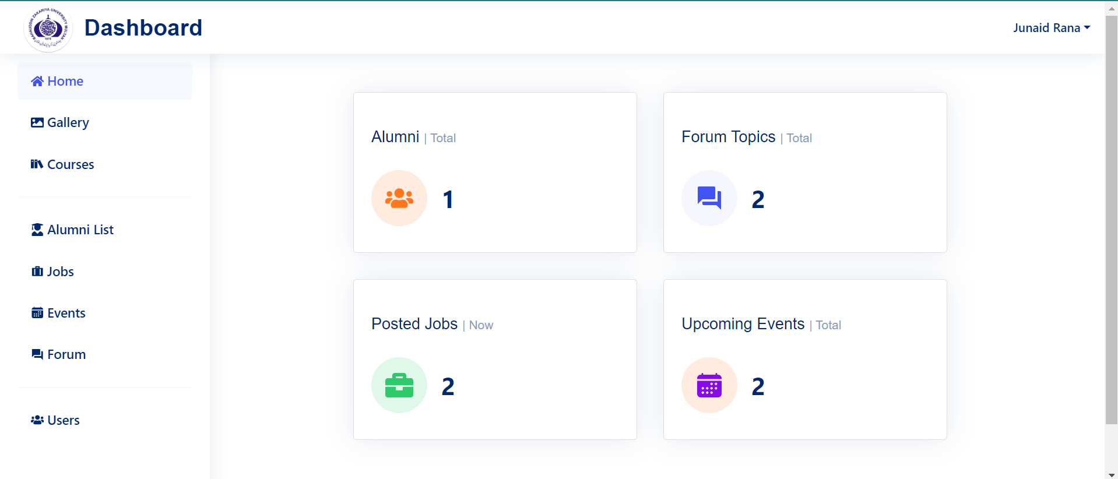Figure 5.2.1 Admin Dashboard Homepage

The purpose of this web page is to provide users with a dashboard interface for accessing and managing various features of the BZU CS Alumni Management System. It includes navigation options, profile management, and access to system functionalities.

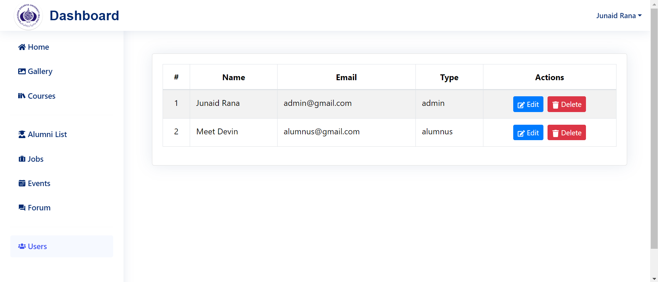**Now it becomes the successful member after signup:**

Figure 5.2.2 Users Management Page

The purpose of this web page is to provide administrators with tools to manage user accounts within the BZU CS Alumni Management System. Administrators can view a list of users, edit existing user details, and delete user accounts.

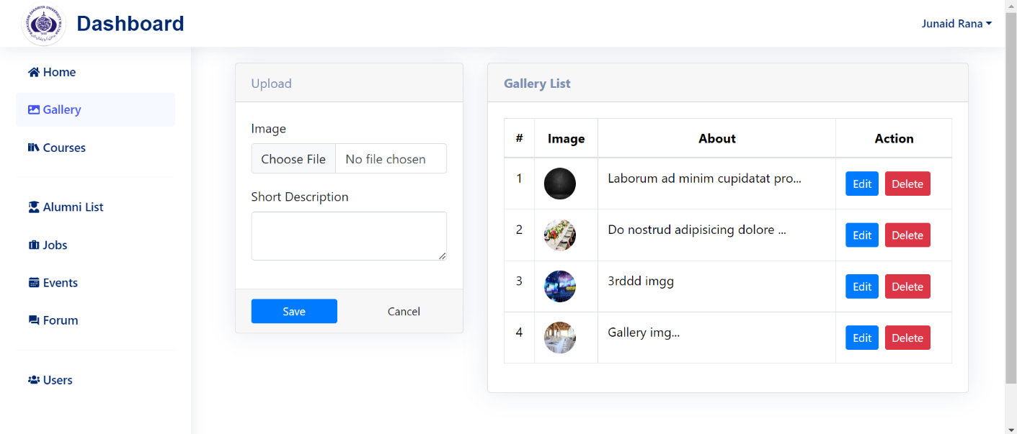**Gallery by the admin section:**

Figure 5.2.3 Gallery Mangement Page

This web page serves as an admin panel for managing the gallery section of the BZU CS Alumni Management System. It allows administrators to upload images with short descriptions, view the existing gallery items, edit their details, and delete them if necessary.

**Course List By admin section:**

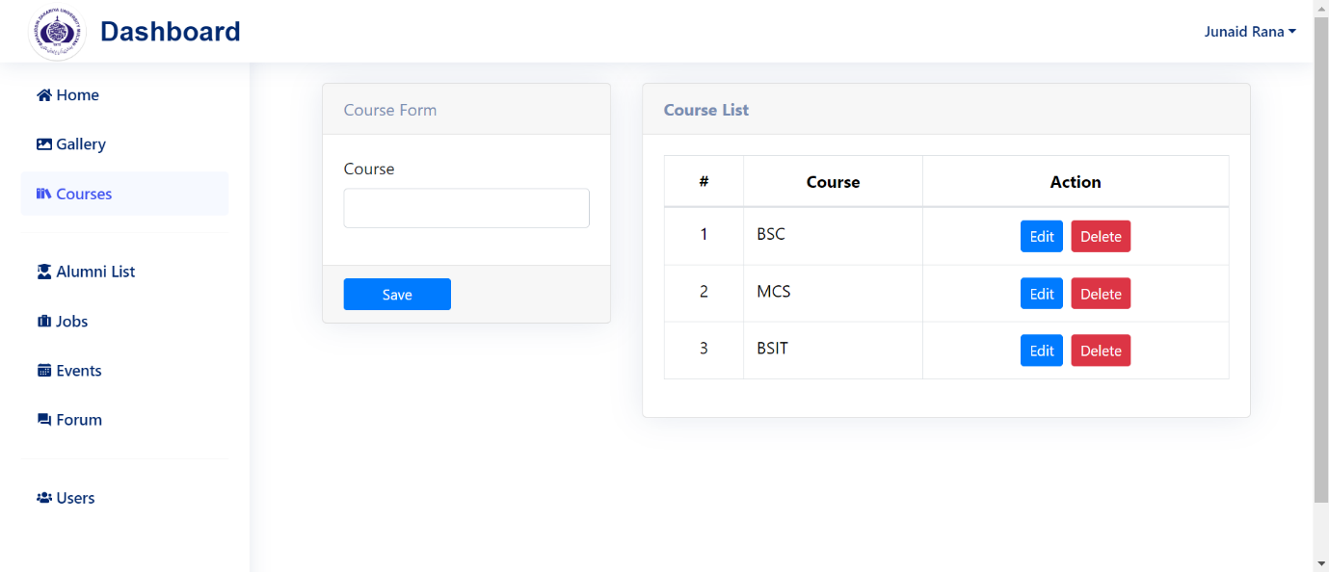Figure 5.2.4 Course Management Page

This web page allows administrators to add new courses, edit existing ones, and delete courses as needed. The page displays a list of courses with options to edit or delete each course. Administrators can also add new courses using the provided form.

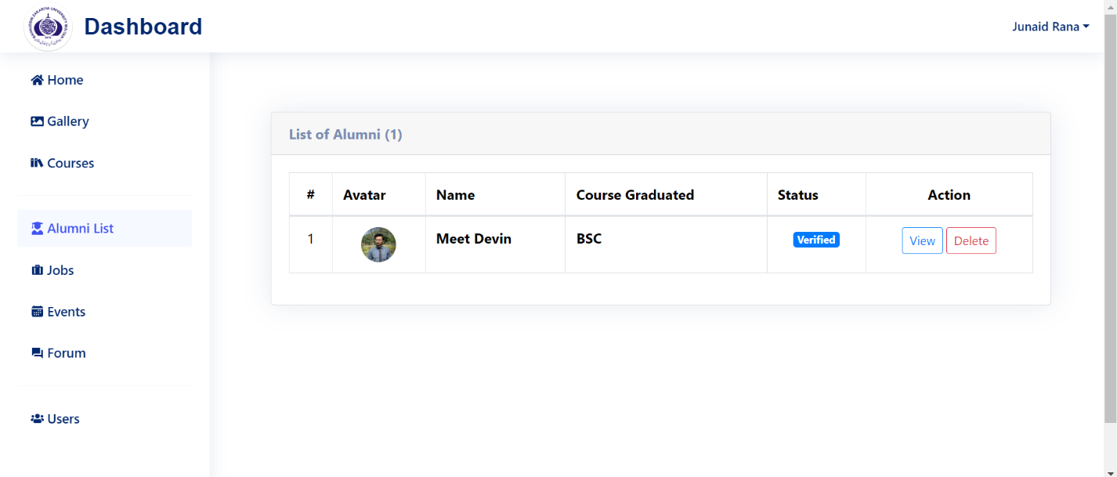**Alumni List:**

Figure 5.2.5 Alumni Management Page

The purpose of this web page is to serve as an alumni management system, allowing administrators to view and verify alumni profiles.

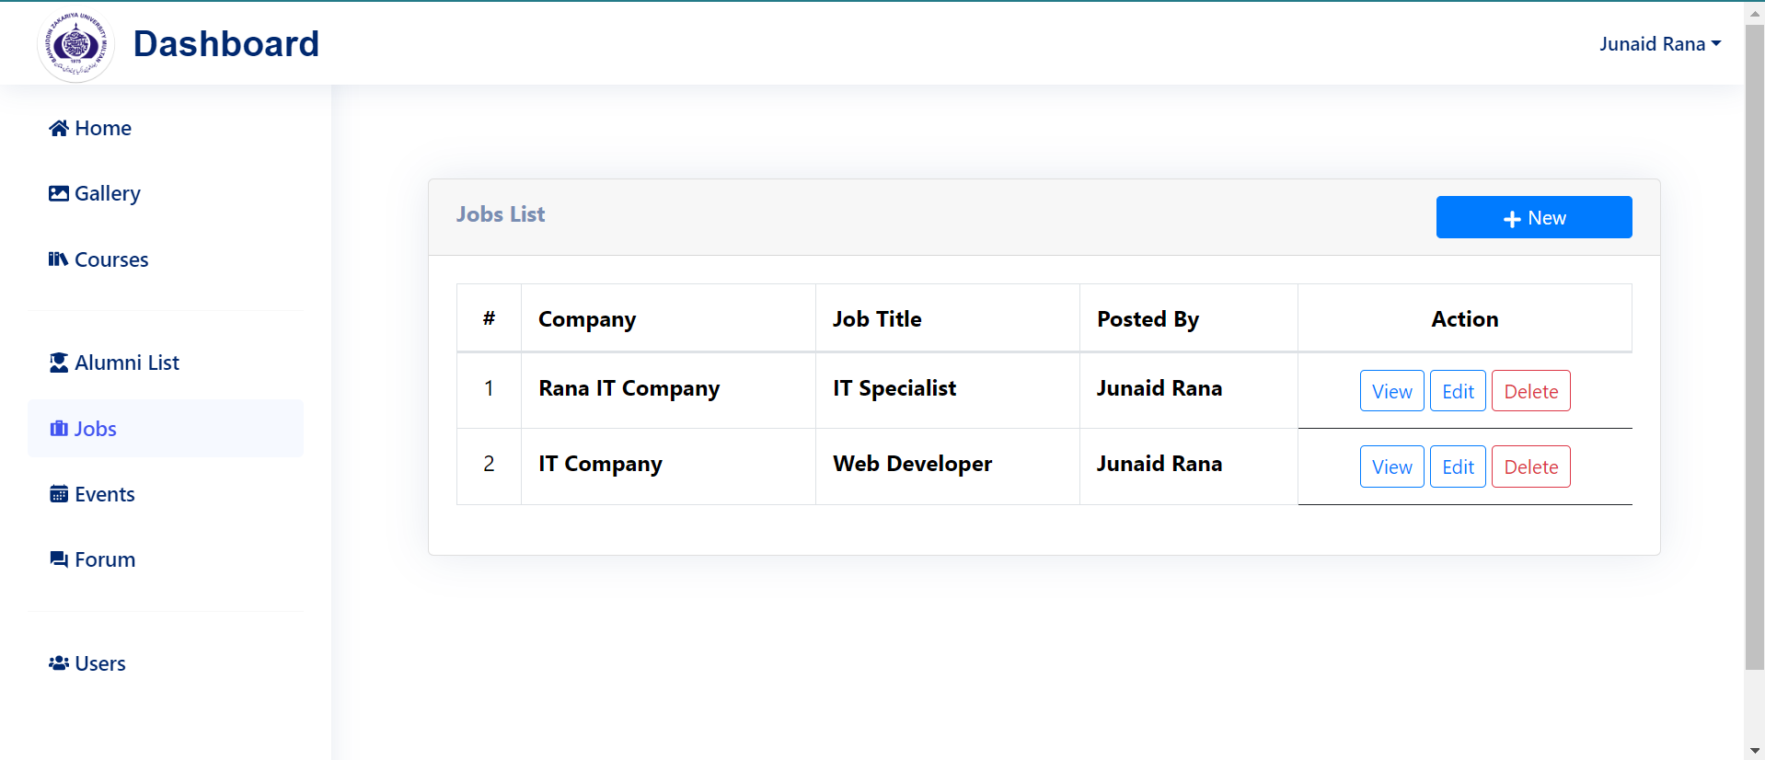**Jobs List By admin section:**

Figure 5.2.6 Jobs Management Page

The Admin Jobs page displays a list of job postings and allows administrators to manage them.. The ManageJobs component provides functionality for adding and editing job postings, on adding jobs it sends emails to all alumni about the job. The ViewJobs component displays detailed information about a selected job posting in a modal window.

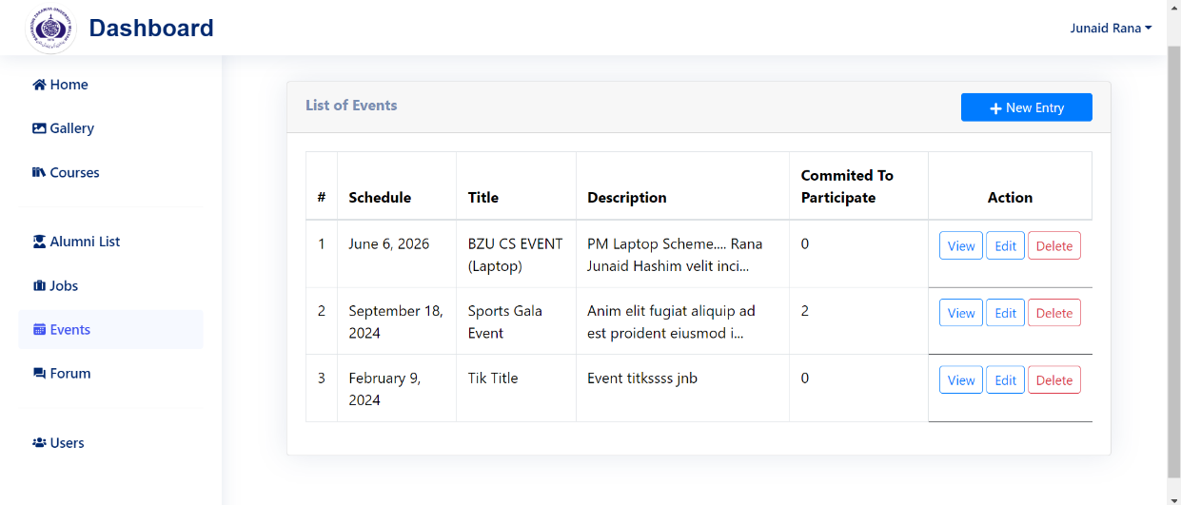**Event Section in admin page:**

Figure 5.2.7 Event Management Page

The Admin Events page allows administrators to manage events. They can view, add, edit, and delete events. This component provides functionality for adding and editing events and displays a list of events with options for management. Authorized users can participate and commit to event.

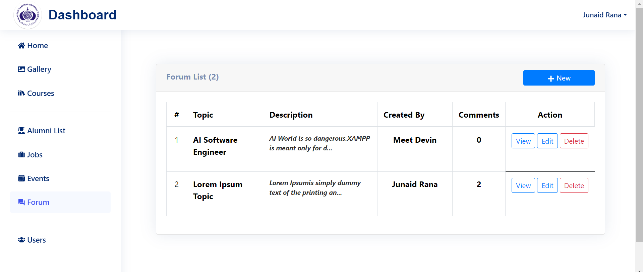**Forum Section:**

Figure 5.2.8 Forum Topics Managment Page

This page is used to manage forum topics or to manage the discussion on forum topic that is posted by the alumni or admin. Alumni communicate betweem them through the forum topic.

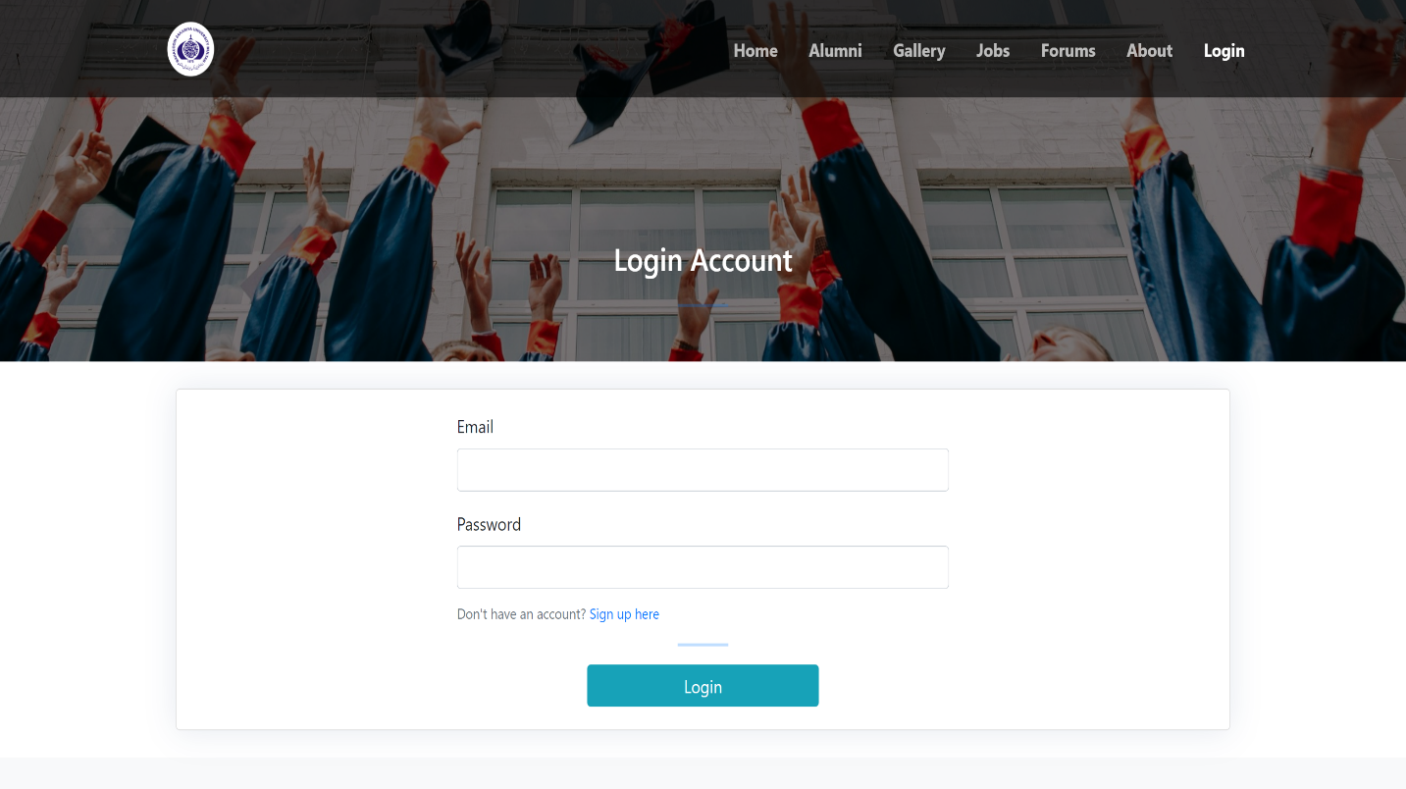**5.3 Login page of website:**

Figure 5.3.1 Login Page

The page is used to login in system by email and password. After login user will be directed to the Homepage. If in case user is already not registered, so one can click on SignUp and create an account first.

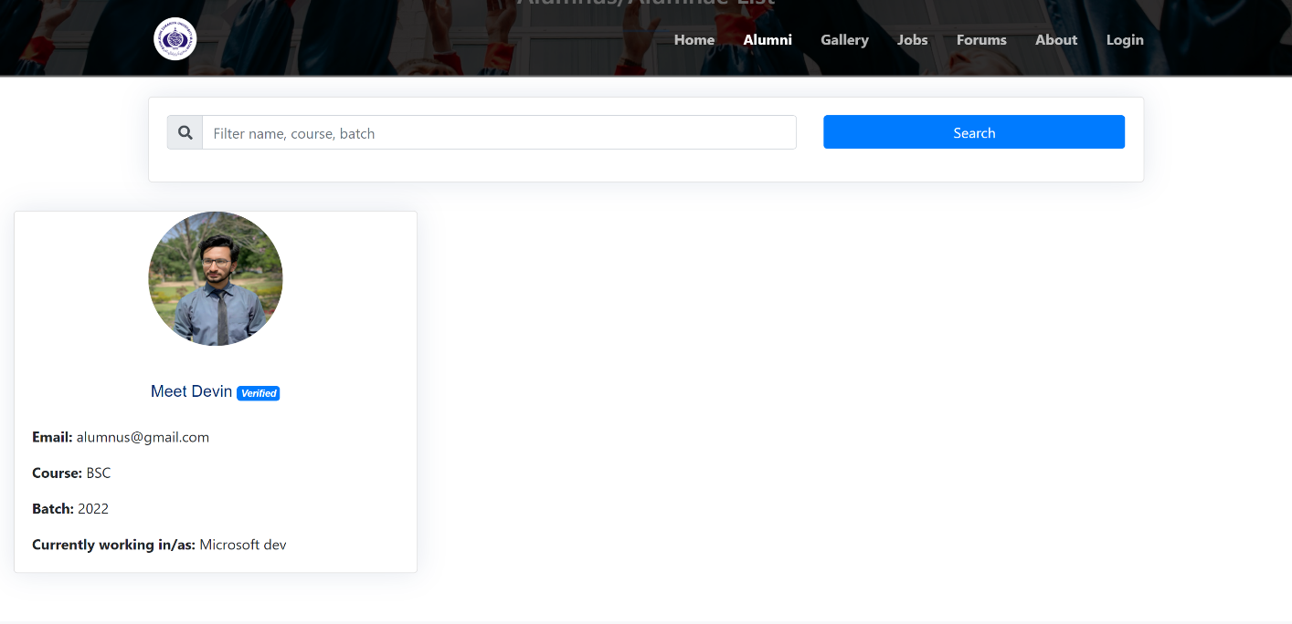**5.4 Alumni Page:**

Figure 5.4.1 Alumni Profiles Page

Alumni information is listed on this page, so the users can search for the alumni and contact through the email and info.

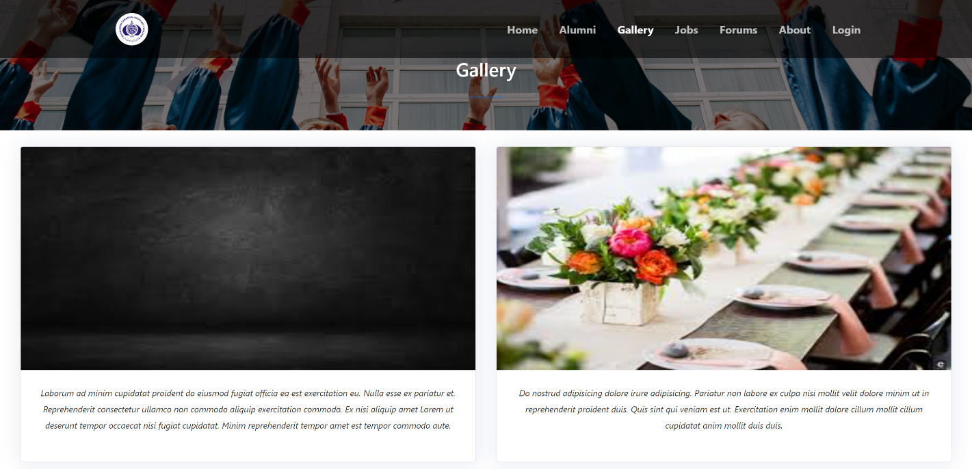**Gallery of the CS department of BZU:**

Figure 5.4.2 Gallery Showcase Page

The information about the events and captured moments of computer science department are shown here, the user can explore the images and read the captions.

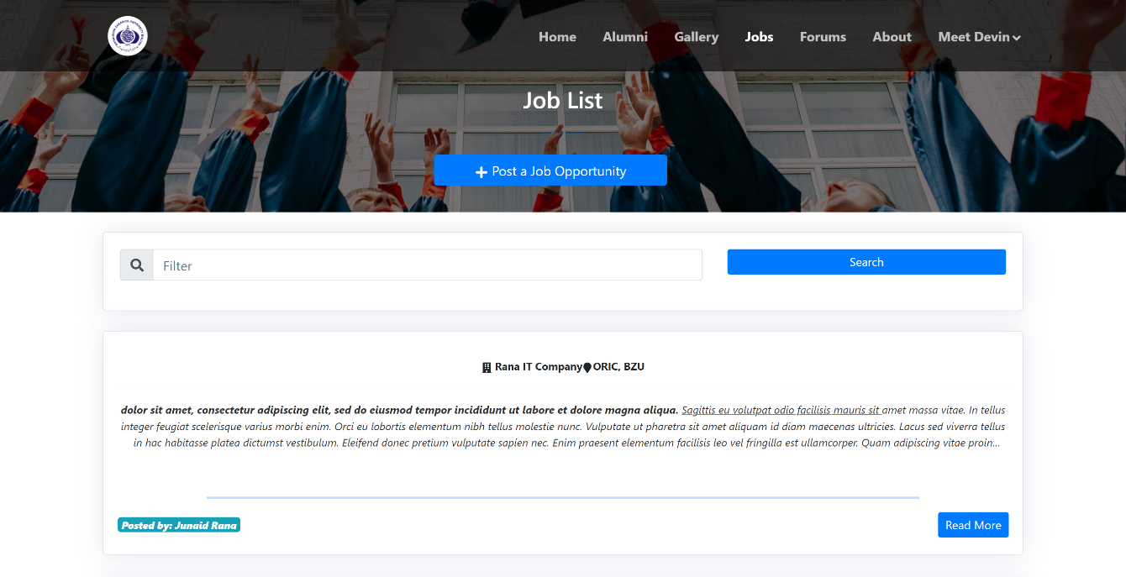**Job Opportunity Page:**

Figure 5.4.3 Job List Page

The alumni can post a job opportunity and also look for posts made by different people. Users can see details on clicking on Read More button. The alumni will be notified about the new posted jobs by email.

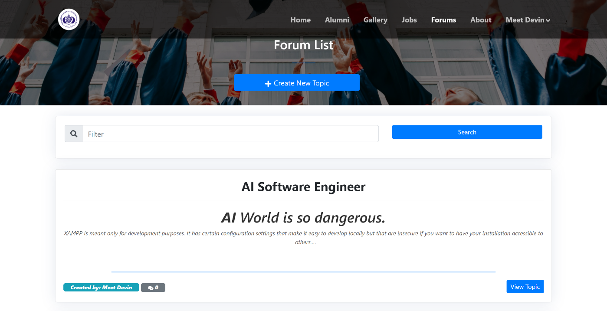**Forums topic:**

Figure 5.4.4 Forum List Page

Users can see the forum topics and verified alumni can post topics or research. Alumni can interact with it and comment their views on it.

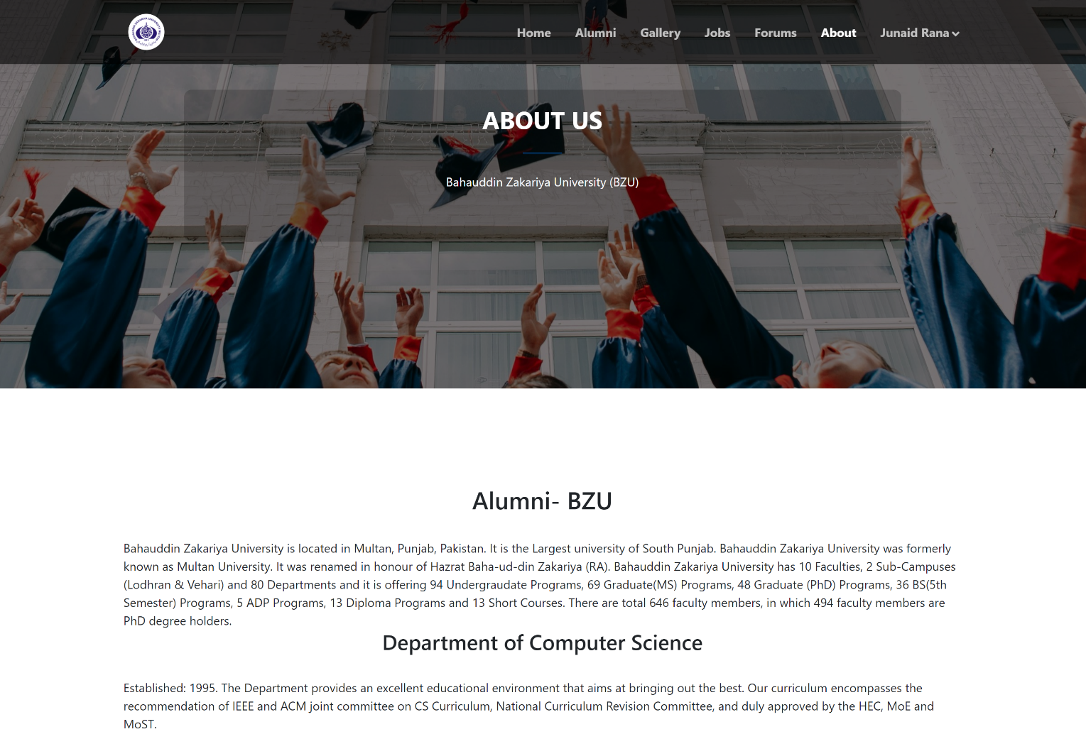**About Page:**

Figure 5.4.5 About Page

The about page contains the history of Computer Science Department of Bahauddin Zakariya University Multan.

**Chapter 6**

**Testing & Evaluation**

* 1. **Introduction**

Software testing is a critical element of software quality assurance and represents the ultimate review of specification, design and coding.

A strategy for software testing integrates software test case design methods into a well planned series of steps that result in the successful construction of software. Testing is the set of activities that can be planned in advance and conducted systematically. The underlying motivation of program testing is to affirm software quality with methods that can economically and effectively apply to both strategic to both large and small-scale systems.

## 6.2 Strategic Approach To Software Testing:

The testing phase of the Alumni Management System built with the MERN stack (MySQL, Express.js, React.js, Node.js) involves several stages to ensure that the system is efficient and meets all specified requirements.

This phase includes unit testing, integration testing, system testing, and user acceptance testing (UAT). Each stage will verify different aspects of the system, from individual components to the entire system functioning as a whole.

A strategy for software testing may also be viewed in the context of the spiral. Unit testing begins at the vertex of the spiral and concentrates on each unit of the software as implemented in source code. Testing progress by moving outward along the spiral to integration testing, where the focus is on the design and the construction of the software architecture. Talking another turn on outward on the spiral we encounter validation testing where requirements established as part of software requirements analysis are validated against the software that has been constructed.

#### 6.2.1 Unit Testing

**Objective:** To validate that each unit of the application performs as expected.

* Unit testing involves testing individual components or modules of the software in isolation.
* Developers typically perform unit testing to verify that each unit functions correctly as per design specifications.
* It helps identify defects early in the development process, making debugging easier and more cost-effective.

#### 6.2.2. Integration Testing

**Objective:** To ensure that different modules or services of the application work together as expected.

* Integration testing focuses on testing the interactions and interfaces between individual components or subsystems of the software.
* It ensures that integrated components work together correctly, exchange data properly, and maintain compatibility.
* Integration testing helps identify integration issues early in the development process, reducing the risk of defects in the final product.

#### 6.2.3. System Testing

**Objective:** To validate the complete and integrated software product to evaluate the system's compliance with its specified requirements.

* System testing evaluates the behavior of the entire software system as a whole.
* It verifies that all components work together seamlessly and meet the specified functional and non-functional requirements.
* System testing includes test scenarios covering different use cases, configurations, and environments to assess the overall quality and reliability of the software.

#### 6.2.4. User Acceptance Testing (UAT)

**Objective:** To ensure the system meets the needs and expectations of the end-users.

* UAT involves testing the software from the end user's perspective to ensure that it meets their requirements and expectations.
* End users or representatives of the target audience perform UAT in a real or simulated environment.
* UAT helps validate that the software fulfills its intended purpose and is user-friendly, thereby enhancing user satisfaction and adoption.

#### 6.2.5. Security Testing

**Objective:** To identify and fix vulnerabilities in the system.

* Security testing aims to uncover vulnerabilities and weaknesses in the software that could be exploited by malicious users or attackers.
* It includes various techniques such as penetration testing, vulnerability scanning, and security code review.
* Security testing is crucial for protecting sensitive data, ensuring compliance with regulations, and maintaining the trust of users.

## 6.3 Evaluation of Testing

The evaluation phase of the Alumni Management System involved a thorough testing process to ensure the system was robust, efficient, and met all specified requirements. The testing was divided into several phases: unit testing, integration testing, system testing, user acceptance testing (UAT), and security testing. Each phase was carefully executed to verify different aspects of the system, from individual components to the entire system functioning as a whole.

#### 6.3.1. Unit Testing

**Objective:** To ensure that each part of the application works correctly.

**Process:**

**-React Components:** I manually tested each React component to ensure proper functionality by:

- Checking form validations by entering valid and invalid data.

- Testing the rendering of components with sample data.

- Observing state changes in response to user interactions.

- **API Routes:** I tested API routes using Postman by:

- Sending various HTTP requests (GET, POST, PUT, DELETE) to each API endpoint and checking the responses.

- Ensuring data was correctly retrieved, updated, or deleted in the database.

- Verifying error messages for invalid inputs or server errors.

- **Database Operations:** Using MySQL Workbench, I tested database operations by:

- Running SQL queries to insert, update, delete, and retrieve data from the database.

- Ensuring data consistency and integrity during these operations.

#### 6.3.2. Integration Testing

**Objective:** To ensure that different parts of the application work together correctly.

**Process:**

-**Interaction between Frontend and Backend**: Using Postman, I checked that the frontend (React) communicated correctly with the backend (Express.js) by:

- Submitting data through frontend forms and verifying backend processing.

- Ensuring data was correctly stored in the MySQL database.

- Checking that data retrieved from the database was correctly displayed on the frontend.

- **Data Flow:** I verified the data flow between the backend and the database by:

- Ensuring data submitted from the frontend was accurately reflected in the database tables.

- Checking that updates or deletions made through the backend were correctly shown on the frontend.

- **User Authentication and Authorization:** I tested user authentication and authorization by:

- Creating test user accounts and verifying the login and logout processes.

- Ensuring role-based access controls were correctly implemented.

#### 6.3.3. System Testing

**Objective:** To check the complete and integrated software product against the specified requirements.

**Process:**

- **User Management:** I tested user management features by:

- Creating, updating, and deleting user accounts.

- Verifying registration, login, and profile management processes.

- Ensuring role-based access control worked correctly.

- **Communication:** I tested communication features by:

- Sending job emails.

- Checking notifications and alerts functionality.

- **Manual Testing:**

I executed detailed test scripts covering all major use cases to ensure the system worked as expected.

#### 6.3.4. User Acceptance Testing (UAT)

**Objective**: To ensure the system meets the needs and expectations of the end-users.

**Process:**

- **Real-world Scenarios:** I involved an end-user, including alumni, admin staff to test the system in a real-world setting.

- **Test Scripts**: I created test scripts that guided users through typical workflows, such as updating profiles, posting jobs, and managing events.

- **Feedback Collection:** I collected feedback from the users and noted any usability issues or missing features.

- **Adjustments:** Based on the feedback, I made necessary adjustments to improve the system's usability and functionality.

#### 6.3.5. Security Testing

**Objective:** To identify and fix vulnerabilities in the system.

**Process:**

- **Data Protection:** I examined how sensitive data such as user password and personal information were stored and protected within the system's database.

- **Access Controls:** I validated that appropriate access controls were in place, restricting access to certain features or data based on user roles and permissions.

- **Authentication and Authorization** I verified the implementation of authentication mechanisms, ensuring that only authorized users could access sensitive data and perform privileged actions.

**Chapter 7**

**conclusion**

* 1. **Summary:**

The Alumni Management System developed for the Computer Science department at Bahauddin Zakariya University Multan serves as a vital platform for communication and connections between the university and its graduates. By leveraging modern technologies such as React Js, Node Js, and Express Js with a MySQL database, the system enables efficient management of alumni data and facilitates smooth interaction between alumni and the university community. The system is divided into two user interfaces: the admin side and the alumni side. The admin side for managing various aspects like job listings, alumni records, events, forums, and the gallery. On the other hand, the alumni side allows users to engage with the community by creating accounts, posting job opportunities, initiating forum topics, and participating in events.

* 1. **Findings:**

The system's implementation has led to several important findings:

* The verification process by the admin is crucial to ensure the authenticity of the user base.
* The system has significantly improved communication channels between alumni, students, and faculty.
* The engagement features have been effective in encouraging alumni to actively contribute to the community, enhancing the network's value.  
    
    
    
  1. **Objective:**

The system aims to:

* Provide a centralized platform for alumni to connect and share opportunities.
* Facilitate the exchange of knowledge and resources within the BZU Multan Computer Science community.
* Support the professional growth of alumni and students through a efficient and user-friendly interface.
  1. **Future Scope:**

It would be very useful if the members of the alumni web site which are former student of **Computer Science department** of **Bahauddin Zakariya University Multan** could directly contact the alumni officer through the web site. The system that was implemented does not offer this functionality. However it is easy to find the contact info of the university department because it will be placed on the footer of website. It should provide the live chat of students and with the administration. That is why it would be useful to be able to set some information, such as contact details as private or public. The alumni web site is used to maintain data of alumni and to provide platform where alumni can see the progress of an institute and also participate in improving institution condition.

**7.5 Conclusion**

The Alumni Management System is a helpful tool for keeping everyone in the Computer Science department connected. It's not just a place to store alumni information; it's a way for people to help each other and make the community stronger. By using this system, we're making things run smoother and helping everyone grow in their careers.

**Chapter 8**

**References**

* <https://cs.bzu.edu.pk/alumni.php>
* <https://react.dev>
* <https://nodejs.org/>
* <https://expressjs.com/>
* <https://www.mysql.com/>